Day 5 data strucures:

1. Write a c program to implement single source shortest algorithm(Dijistra’s)?

Code:

#include<stdio.h>

#include<conio.h>

#define INFINITY 9999

#define MAX 10

void dijkstra(int G[MAX][MAX],int n,intstartnode);

int main()

{

int G[MAX][MAX],i,j,n,u;

printf("Enter no. of vertices:");

scanf("%d",&n);

printf("\nEnter the adjacency matrix:\n");

for(i=0;i<n;i++)

for(j=0;j<n;j++)

scanf("%d",&G[i][j]);

printf("\nEnter the starting node:");

scanf("%d",&u);

dijkstra(G,n,u);

return 0;

}

void dijkstra(int G[MAX][MAX],int n,intstartnode)

{

int cost[MAX][MAX],distance[MAX],pred[MAX];

int visited[MAX],count,mindistance,nextnode,i,j;

for(i=0;i<n;i++)

for(j=0;j<n;j++)

if(G[i][j]==0)

cost[i][j]=INFINITY;

else

cost[i][j]=G[i][j];

for(i=0;i<n;i++)

{

distance[i]=cost[startnode][i];

pred[i]=startnode;

visited[i]=0;

}

distance[startnode]=0;

visited[startnode]=1;

count=1;

while(count<n-1)

{

mindistance=INFINITY;

for(i=0;i<n;i++)

if(distance[i]<mindistance&&!visited[i])

{

mindistance=distance[i];

nextnode=i;

}

visited[nextnode]=1;

for(i=0;i<n;i++)

if(!visited[i])

if(mindistance+cost[nextnode][i]<distance[i])

{

distance[i]=mindistance+cost[nextnode][i];

pred[i]=nextnode;

}

count++;

}

for(i=0;i<n;i++)

if(i!=startnode)

{

printf("\nDistance of node%d=%d",i,distance[i]);

printf("\nPath=%d",i);

j=i;

do

{

j=pred[j];

printf("<-%d",j);

}while(j!=startnode);

}

}

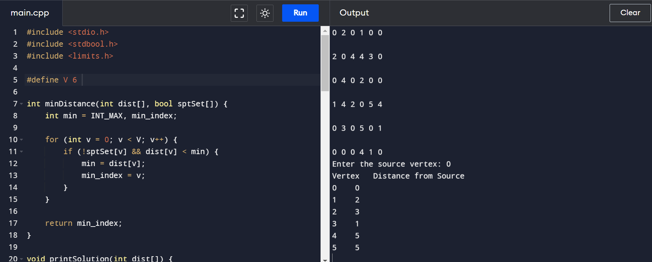

1. Write a c program to implement minimum spanning tree from prim’s algorithm?

Code:

#include <stdio.h>

#include <stdlib.h>

#include <limits.h>

#define V 5

int minKey(int key[], int mstSet[]) {

int min = INT_MAX, min_index;

for (int v = 0; v < V; v++) {

if (!mstSet[v] && key[v] < min) {

min = key[v];

min_index = v;

}

}

return min_index;

}

void printMST(int parent[], int graph[V][V]) {

printf("Edge Weight\n");

for (int i = 1; i< V; i++) {

printf("%d - %d %d \n", parent[i], i, graph[i][parent[i]]);

}

}

void primMST(int graph[V][V]) {

int parent[V];

int key[V];

int mstSet[V];

for (int i = 0; i< V; i++) {

key[i] = INT_MAX;

mstSet[i] = 0;

}

key[0] = 0;

parent[0] = -1;

for (int count = 0; count < V - 1; count++) {

int u = minKey(key, mstSet);

mstSet[u] = 1;

for (int v = 0; v < V; v++) {

if (graph[u][v] && !mstSet[v] && graph[u][v] < key[v]) {

parent[v] = u;

key[v] = graph[u][v];

}

}

}

printMST(parent, graph);

}

int main() {

int graph[V][V];

printf("Enter the adjacency matrix for the graph:\n");

for (int i = 0; i< V; i++) {

for (int j = 0; j < V; j++) {

scanf("%d", &graph[i][j]);

}

}

primMST(graph);

return 0;

}

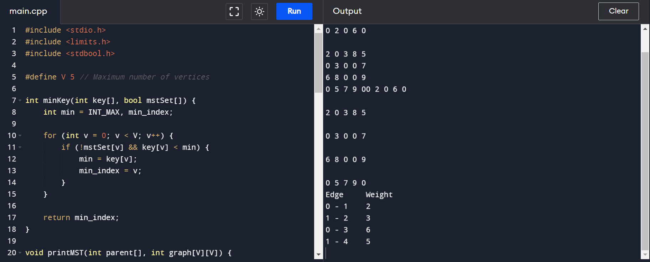

1. Write a c program to implement Kruskal’s algorithm?

Code:

#include <stdio.h>

#include <stdlib.h>

int comparator(const void* p1, const void* p2)

{

const int(*x)[3] = p1;

const int(*y)[3] = p2;

return (*x)[2] - (*y)[2];

}

void makeSet(int parent[], int rank[], int n)

{

for (int i = 0; i< n; i++) {

parent[i] = i;

rank[i] = 0;

}

}

int findParent(int parent[], int component)

{

if (parent[component] == component)

return component;

return parent[component]

= findParent(parent, parent[component]);

}

void unionSet(int u, int v, int parent[], int rank[], int n)

{

u = findParent(parent, u);

v = findParent(parent, v);

if (rank[u] < rank[v]) {

parent[u] = v;

}

else if (rank[u] > rank[v]) {

parent[v] = u;

}

else {

parent[v] = u;

rank[u]++;

}

}

void kruskalAlgo(int n, int edge[n][3])

{

qsort(edge, n, sizeof(edge[0]), comparator);

int parent[n];

int rank[n];

makeSet(parent, rank, n);

int minCost = 0;

printf(

"Following are the edges in the constructed MST\n");

for (int i = 0; i< n; i++) {

int v1 = findParent(parent, edge[i][0]);

int v2 = findParent(parent, edge[i][1]);

int wt = edge[i][2];

if (v1 != v2) {

unionSet(v1, v2, parent, rank, n);

minCost += wt;

printf("%d -- %d == %d\n", edge[i][0],

edge[i][1], wt);

}

}

printf("Minimum Cost Spanning Tree: %d\n", minCost);

}

int main()

{

int edge[5][3] = { { 0, 1, 10 },

{ 0, 2, 6 },

{ 0, 3, 5 },

{ 1, 3, 15 },

{ 2, 3, 4 } };

kruskalAlgo(5, edge);

return 0;

}

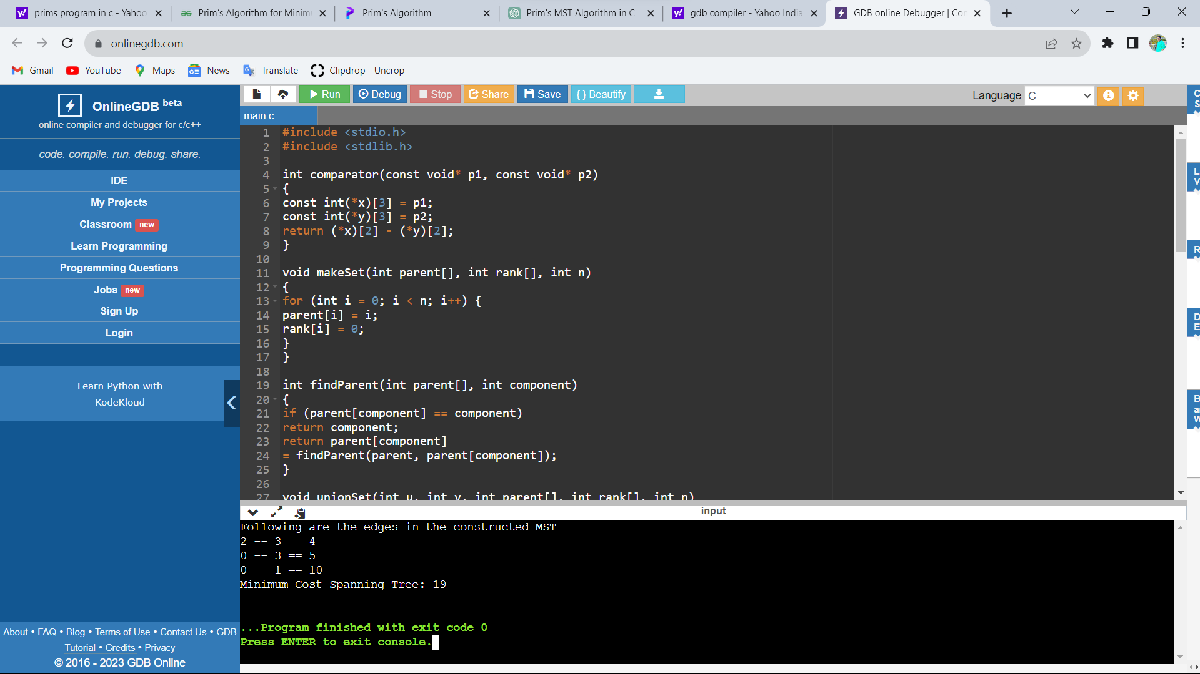

1. Write a c program to implement the graph traversals?

Code:

#include <stdio.h>

#include <stdlib.h>

struct node

{

int vertex;

struct node *next;

};

struct node *createNode(int);

struct Graph

{

int numVertices;

struct node **adjLists;

int *visited;

};

struct Graph *createGraph(int vertices)

{

struct Graph *graph = malloc(sizeof(struct Graph));

graph->numVertices = vertices;

graph->adjLists = malloc(vertices * sizeof(struct node *));

graph->visited = malloc(vertices * sizeof(int));

int i;

for (i = 0; i< vertices; i++)

{

graph->adjLists[i] = NULL;

graph->visited[i] = 0;

}

return graph;

}

void addEdge(struct Graph *graph, int src, int dest)

{

struct node *newNode = createNode(dest);

newNode->next = graph->adjLists[src];

graph->adjLists[src] = newNode;

newNode = createNode(src);

newNode->next = graph->adjLists[dest];

graph->adjLists[dest] = newNode;

}

struct node *createNode(int v)

{

struct node *newNode = malloc(sizeof(struct node));

newNode->vertex = v;

newNode->next = NULL;

return newNode;

}

void printGraph(struct Graph *graph)

{

int v;

for (v = 0; v < graph->numVertices; v++)

{

struct node *temp = graph->adjLists[v];

printf("\n Adjacency list of vertex %d\n ", v);

while (temp)

{

printf("%d -> ", temp->vertex);

temp = temp->next;

}

printf("\n");

}

}

void bfs(struct Graph *graph, int startVertex)

{

struct node *queue = NULL;

graph->visited[startVertex] = 1;

enqueue(&queue, startVertex);

while (!isEmpty(queue))

{

printQueue(queue);

int currentVertex = dequeue(&queue);

printf("Visited %d ", currentVertex);

struct node *temp = graph->adjLists[currentVertex];

while (temp)

{

int adjVertex = temp->vertex;

if (graph->visited[adjVertex] == 0)

{

graph->visited[adjVertex] = 1;

enqueue(&queue, adjVertex);

}

temp = temp->next;

}

}

}

int isEmpty(struct node *queue)

{

return queue == NULL;

}

void enqueue(struct node **queue, int value)

{

struct node *newNode = createNode(value);

if (isEmpty(*queue))

{

*queue = newNode;

}

else

{

struct node *temp = *queue;

while (temp->next)

{

temp = temp->next;

}

temp->next = newNode;

}

}

int dequeue(struct node **queue)

{

int nodeData = (*queue)->vertex;

struct node *temp = *queue;

*queue = (*queue)->next;

free(temp);

return nodeData;

}

void printQueue(struct node *queue)

{

while (queue)

{

printf("%d ", queue->vertex);

queue = queue->next;

}

printf("\n");

}

int main(void)

{

struct Graph *graph = createGraph(6);

printf("\nWhat do you want to do?\n");

printf("1. Add edge\n");

printf("2. Print graph\n");

printf("3. BFS\n");

printf("4. Exit\n");

int choice;

scanf("%d", &choice);

while (choice != 4)

{

if (choice == 1)

{

int src, dest;

printf("Enter source and destination: ");

scanf("%d %d", &src, &dest);

addEdge(graph, src, dest);

}

else if (choice == 2)

{

printGraph(graph);

}

else if (choice == 3)

{

int startVertex;

printf("Enter starting vertex: ");

scanf("%d", &startVertex);

bfs(graph, startVertex);

}

else

{

printf("Invalid choice\n");

}

printf("What do you want to do?\n");

printf("1. Add edge\n");

printf("2. Print graph\n");

printf("3. BFS\n");

printf("4. Exit\n");

scanf("%d", &choice);

}

return 0;

}

